Caroline Lewis and Shokhsanam Uktamova
Mini Project 1A
CS 4001
Due Feb 2, 11:59pm
To Do:
Fear mechanism simulation on a local VS Code:
- Apply a 0.2 nA current. What is the oscillation frequency? What emotional state can it correspond to?

With a 0.2 nA current, the oscillation frequency is 3.918 Hz. This oscillation frequency is low and corresponds with a no-fear / baseline emotional state where amygdala neurons spike infrequently.

- Apply a 1.0 nA current. What is the oscillation frequency? What emotional state can it correspond to?

With a 1.0 nA current, the oscillation frequency is 19.54 Hz. The emotional state that this oscillation frequency corresponds to is fear where the neurons in the amygdala are spiking rapidly.

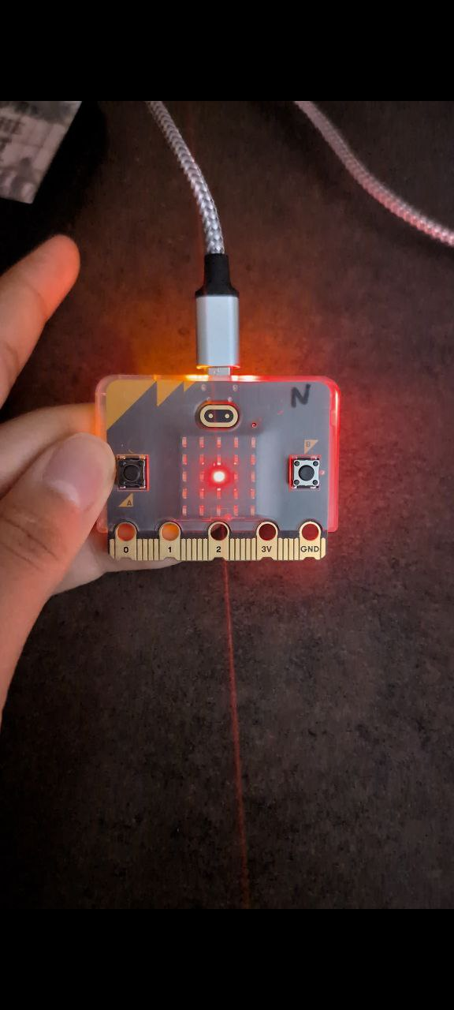

Ps. We tried the micro:bit flashing part later at home, and it worked just fine. Screenshots above were taken before that.

Computational Thinking Steps
According to Gemini, this approach focuses on the logical implementation of the brain circuit model and the Cyberinfrastructure (CI) workflow; follows this order:
Decomposition -> Pattern recognition -> Abstraction -> Algorithmic design
Decomposition: Breaking the end-to-end CI workflow into distinct modules: the input parameter interface, the Python-based NEURON brain circuit model, and the output communication to the micro:bit LEDs.
Pattern Recognition: Identifying how different current inputs (e.g., 0.2 nA vs. 1.0 nA) consistently produce distinct oscillation frequencies that map to discrete emotional states (baseline vs fear).
Abstraction: Focuses on modeling the complex biological amygdala using a simplified NEURON software simulation which can be used to predict the respective firing rate of the amygdala.
Algorithmic Design: The created simple workflow follows:
1. The user inputs and can change the current amount
2. The model calculates the amygdala's firing rate.
3. The system translates that rate into a visual signal (low flashing vs. rapid flashing) for the micro:bit hardware.
Design Thinking Steps
This approach focuses on user interaction and the physical representation of the simulated "brain."
Empathize: Recognizing the difficulty in visualizing internal brain states and translating abstract neural activity into an intuitive, observable signal.
Define: The goal is to design a system where a user can change inputs and receive an immediate, intuitive visual prediction of a brain "state."
Ideate: The micro:bit hardware can be used to represent the amygdala data into the physical form by flashing in different frequencies.
Prototype: Making sure that the simulation works in different CI platforms, like a local PC.
Test: It is important to verify that the oscillation frequency output (such as 19.54 Hz for fear) and the flicker.py script are effectively flashing the LEDs at the appropriate relative speed.

